SUPPLEMENTARY FILE for “Millisecond-scale Real-time Scheduling of Buses: A Controller-based Approach” by Wang et al.

*A. The Forward Detection Approach (FDA)*

For online bus scheduling, the controller must make decisions in real-time. However, there is a delay during the transition of bus state and duty type. Take transition rule (b) for example. As shown in Fig. A, according to transition rule (b), the controller should convert bus $v$ to a “sleeping state” peak type bus at time $a_{4}$ since the continuous rest time of bus $v$ exceeds the threshold value $δ$, but the controller does not know the length of continuous rest time at time $a_{4}$ until the time $t_{r}$. In this paper, we propose a *forward detection approach* (FDA) to allow the controller to convert the bus duty type at time $a_{4}$. At time $b_{4}$, a simulation of the bus’s scheduling process in the period $\left[b_{4},a_{4}+δ\right]$ is performed. The bus $v$ will be converted to a peak type bus at the time $a_{4}$ if its continuous rest time is greater than $δ$ during the simulation; otherwise, the bus is still a short type. Thus, the controller can know whether bus $v$ is converted to a peak type at time $a_{4}$.

The simulation scheduling procedure is described as follows. At the current departure time *T*[*i*] in timetable *T*, the bus $v^{*}$ for departure and its duty type are given by Algorithm 2 in Section IV-B. If bus $v^{*}$ is a short type bus with an even number of trips at the current departure time *T*[*i*], then FDA is used to decide whether $v^{*}$ should be converted to a peak type bus at *T*[*i*]. Algorithm A presents the pseudocode of FDA.

In line 1, the duty type of the bus $v^{*}$ which is selected by the controller to depart at current departure time *T*[*i*] is initialized by DTC. Lines 2 to 14 describe the forward detection procedure that aims to determine whether bus $v^{*}$ is converted to a peak type bus at *T*[*i*]. The procedure is as follows. If bus $v^{*}$ is chosen again for departure before its continuous rest time exceeds the threshold $δ$, its duty type is not updated as a peak type bus at *T*[*i*]. If bus $v^{*}$ is not chosen and its continuous rest time exceeds $δ$, indicating that bus $v^{*}$ has a long rest interval greater than $δ$, its duty type is updated as a peak type at *T*[*i*].

|  |  |
| --- | --- |
| **Algorithm A: Forward Detection Approach.** | |
| **Input:** The controller; the timetable *T*;  The sequence number *i* of the current departure time in *T*; $v^{*}$ : The bus that departs at *T*[*i*]. | |
| **Output:** The converted duty type of bus $v^{*}$ at *T*[*i*]. | |
| **Notation:** *T*[*i*]: The *i*-th departure time in *T.*  *j*: The sequence number of the departure time after *i*. : The total number of departure times in *T*. | |
| **1** | **Initialization:**  The duty type of bus $v^{*}$ is determined by DTC. |
| **2** | **if** bus $v^{*}$ is a short type bus with an even number of trips at *T*[*i*] **then** |
| **3** | **for** *j*= *i+*1 to  **do** |
| **4** | Obtain the information of each bus at *T*[*j*] from the simulation environment. |
| **5** | DTC is used to update the state and duty type of each bus. |
| **6** | BS is used to select a bus *v* for departure at *T*[*j*]. |
| **7** | **if** *v* = $v^{*}$**then** |
| **8** | **Jump to line 15** |
| **9** | **end if** |
| **10** | **if** bus $v^{*}$ rests continually for more than $δ$ minutes at *T*[*j*] **then** |
| **11** | Convert $v^{*}$ to a peak type bus with “sleeping state”. |
| **12** | **end if** |
| **13** | **end for** |
| **14** | **end if** |
| **15** | **Output:** The duty type of bus $v^{*}$ at *T*[*i*]. |

**Fig. A.** Delay of bus duty type transition.

++++++++++++++++++++++++++++++++++++++++++++

++++++++++

++++++

+

+-

+++++++++++

**Fig. 5.** Delay of vehicle type transition.



|  |  |
| --- | --- |
| (a) Line 4 | (b) Line 59 |



|  |  |
| --- | --- |
| (c) Line 60 | (d) Line k1 |



|  |  |
| --- | --- |
| (e) Line 70 | (f) Line from Nanjing |

**Fig. B.** Number of trips executed by buses in the best scheduling solution (schemes) for each bus line.

B. The Design of Priority Value Equation in BS

**

|  |
| --- |
| (a) A bus scheduling scheme generated by a controller with optimized parameters |

**

|  |
| --- |
| (b) A bus scheduling scheme generated by a controller with random parameters |

**Fig. C.** Comparation of the optimized controller and the controller with random parameters.

In our paper, the priority value formula is given as follows:

|  |  |
| --- | --- |
| $${ S}_{i}^{ }={\left(\frac{Γ_{i}}{G_{i}}\right)}^{α}\left({B_{i}}^{β}+γL_{i}\right)$$ | (A) |

To reduce the number of buses with odd-numbered trips, the parameter $γ$ (the coefficient of $L_{i}$) should be large, to make the controller tend to select a bus with odd-numbered trips to cover the current departure time. As a result, the bus would have even-numbered trips after it covering the time.

If the continuous rest time of a bus is too long, the utilization rate of the bus is low, thereby increasing the number of buses used. To avoid this, the controller should select the buses with longer rest time. We observe that the linear weighting of $B_{i}$ (i.e., using the form of ${βB}_{i}$) has not enough impact on the selection of buses with long rest time, such that we use the exponential weighting. Experiments show that ${B_{i}}^{β}$ and $γL_{i}$ have similar magnitude, so we add them together.

Short type buses with 2 or 4 trips have a low vehicle utilization rate, increasing the number of buses used. The ratio of the number of remaining trips $Γ_{i}$ to the remaining working time $G_{i}$, namely $Γ_{i}/G_{i }$, indicates the number of trips that need to be completed in unit working time. This ratio value reflects the urgent degree to finish the remaining trips of $v_{i}$. The higher this ratio value is, the earlier bus $v_{i}$ should depart. To enhance the influence of this ration on the selection of buses, we use exponential weighting for this ratio. We find that this ratio has a significant impact on the results of almost all instances, so we multiply it with the term $\left({B_{i}}^{β}+γL_{i}\right)$.

C. The Distribution of the Number of Trips

For each problem instance, the distribution of the number of trips in the best scheduling solutions (schemes) generated by CBSA, ALNS, and manual method is shown in Fig. B, respectively. Take line 4 for example, the first, sixth, and ninth bars in Fig. B (a) indicate that the solution of CBSA has 19 buses with 10 trips, 5 buses with 6 trips, and 1 bus with 4 trips, respectively. For line 4, a bus with not less than 8 trips is considered a long type bus, thus CBSA generates 19 long type buses, each of which has 10 trips. The solution of ALNS has 20 long type buses, but only 12 of them contain 10 trips. The manual scheduling scheme has only 15 long type buses. Fig. B shows that the solutions generated by CBSA have more buses with a large number of trips than those of ALNS and manual method, such that CBSA generates a scheduling solution with a smaller number of buses.



|  |  |
| --- | --- |
| (a) Parameter $α$ | (b) Parameter |



|  |  |
| --- | --- |
| (c) Parameter $γ$ | (d) Parameter $δ$ |

**Fig. D.** Changes of parameters’ values along with population evolution of PSO.

D. The Effect of Optimizing Controller’s Parameters

The controller in CBSA is optimized by PSO. To observe the effect of such optimization, we take bus line 60 as an example to show scheduling results generated by a controller with random parameters. In the controller, its parameters, $α,β,γ,and δ$, are given randomly. The scheduling scheme generated by the controller is shown in Fig. C (b). As the controller still performs online scheduling as CBSA does, the scheduling scheme can cover all departure times in the timetable. Compared with the scheduling scheme (shown in Fig. C (a)) generated by the optimized controller, the scheduling scheme generated by the controller with random parameters needs two more buses. Buses 13 and 14 have only 2 trips and 1 trip, respectively, such that their utilization rate is very low, which increases the operation cost of the bus company. In addition, buses 11 and 14 have an odd number of trips, which is inconvenient for drivers to go home from the CPs. Therefore, the controller with random parameters has worse performance than the optimized controller.

To observe the optimization procedure of controller’s four parameters, we take the scheduling scheme of line 60 in Fig. C (a) as an example. For the scheme in Fig. C (a), the value of the four controller’s parameters $α,β,γ,and δ$ are 3.30, 3.85, 1387 and 47, respectively. The changes of parameters’ values along with the population evolution of PSO are shown in Fig. D. The population of PSO involves 100 particles, each of which consists of the four parameters. In Fig. D, each blue dot represents the parameter values involved in the *g-best*, i.e., excellent parameter values. Each yellow dot represents the parameter values involved in other particles in the population. Fig. D shows that along with the increase in the number of generations, each parameter gradually converges to the corresponding parameter value in the *g-best*. For each parameter, most of particles in the population involve the parameter values in the *g-best* after 30 generations. Take parameter $δ$ for example, after 30 generations, the parameter values of a large number of particles are in the range of [35, 50], while the best parameter values (blue dots) are in the range of [40, 48].

E. CBSA Schedules Buses under Traffic Congestion

In practical bus operation, a bus scheduling scheme may become invalid when traffic congestion occurs. Differing from existing approaches that generate a scheduling scheme in advance and then schedule buses according to it, CBSA can dispatch buses online to effectively handle traffic congestion.

**

**Fig. E.** A bus scheduling scheme generated by CBSA for bus line 60.

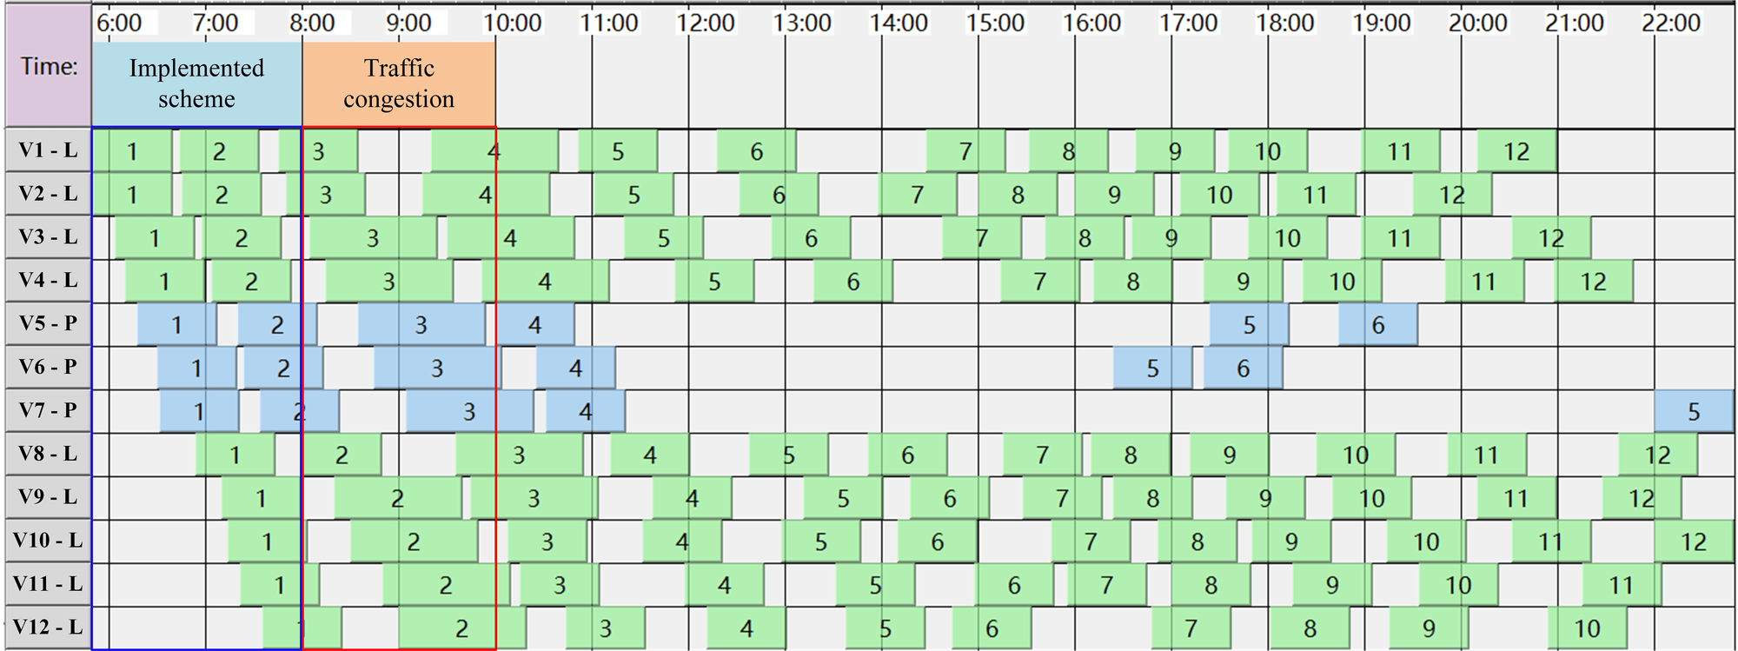

**Fig. F.** Online schedule buses via CBSA under traffic congestion.

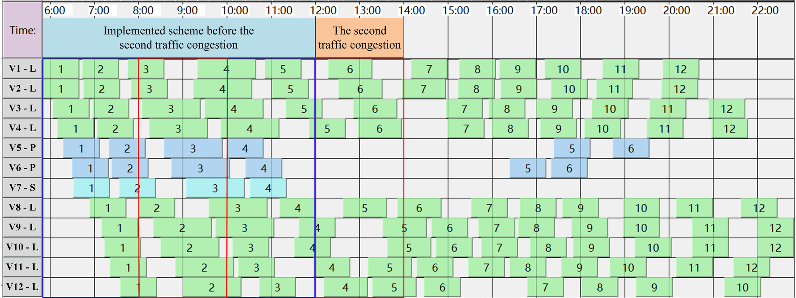

**Fig. G.** Online schedule buses via CBSA under the second traffic congestion.

We take bus line 60 as an example to show the scheduling performance of CBSA under traffic congestion. Assume that traffic congestion occurs from 8 am to 10 am, which increases the travel time of each trip starting in this period by 30 minutes. In Section V-A, an optimized controller of CBSA is obtained to schedule buses for bus line 60, and the scheduling scheme under normal traffic conditions is shown in Fig. E.

|  |  |  |  |
| --- | --- | --- | --- |
| TABLE A  BUS INFORMATION AT THE 101-th DEPARTURE TIME (18:30 PM) OF BUS LINE 60 | | | |
| Bus number, V | 1 | 8 | 10 |
| Bus state | Working | Working | Working |
| Bus duty type | Long type | Long type | Peak type |
| Bus working time, W | 760 minutes | 696 minutes | 192 minutes |
| Remaining working time, G | 200 minutes | 264 minutes | 288 minutes |
| The number of completed trips, E | 10 | 9 | 3 |
| The number of remaining trips, Γ | 2 | 3 | 3 |
| Continuous rest time since last trip, B | 28 minutes | 4 minutes | 16 minutes |
| Priority value, S | **0.093661** | 0.000079 | 0.012427 |

When traffic congestion happens, the optimized controller is used to perform online scheduling, i.e., the controller makes decisions at each departure time in $T_{t}=\left\{y|y>t,y∈T\right\}$ in chronological order, and the scheduling result is shown in Fig. F. We can see that scheduling schemes in Figs. E and F are identical before the congestion. When traffic congestion occurs, the travel time of all buses is prolonged during the congestion period. To cover all departure times in $T_{t}$, peak type buses V10 and V4 in Fig. E are awakened at about 10:00 and 12:00, respectively, and then some trips are appended to them. Thus, the two buses are converted to long type buses. Besides, short type bus V5 in Fig. E is awakened at about 17:20, such that it is converted to a peak type bus. The number of trips in long type buses V6 and V7 is reduced, and the two buses are converted to peak type buses. All the above decisions are made online by CBSA to achieve the full coverage of all departure times in the timetable without adding any bus. In the Supplementary File, we describe in detail how CBSA uses the buses’ information to make a decision at a departure time in $T_{t}$ to select a bus.

Traffic congestion may happen more than once in a day. Assume that congestion happens again from 12:00 to 14:00, and causes 10 minutes increase in travel time. The optimized controller used to handle the first congestion is further used to deal with the second congestion. The scheduling result is shown in Fig. G. It can be seen that the scheduling schemes in Figs. F and G are identical before the second traffic congestion. When the second congestion occurs, the controller achieves the full coverage of all departure times in the timetable via online decisions, without adding any bus.

F. Decision-making Process of CBSA

A departure time in the timetable T is randomly selected to see the decision-making process of CBSA. The 101-th departure time (18:30) in the timetable of CP1 is chosen. During the scheduling process to create the scheduling scheme in Fig. C(a), at the 101-th departure time, CP1 has 3 buses, whose information is shown in Table A. According to Algorithm 1, the decision-making process of CBSA is as follows.

1) A particle in the population is decoded into a controller. Assume that the particle’s position is {3.30, 3.85, 1387, 47}, then values of the controller’s parameters $α,β,γ,and δ$ are set to be 3.30, 3.85, 1387 and 47, respectively. The information of each bus, including $Γ_{ }$, $G$, $B$ and $L$, can be obtained in the scheduling procedure, as shown in Table A. Thus, the priority value of each bus can be calculated by formula (B). For a short type bus with an even number of trips, if it has a continuous rest time greater than 47 minutes, it is converted to a peak type bus.

2) At the 101-th departure time, all the 3 buses are in “working state”. At this departure time, DTC checks each bus according to transition rules (a)-(g), and does not change the state and type of any bus.

3) BS selects a bus to depart at the 101-th departure time (cover the departure time). According to formula (B) and the buses’ information in Table A, BS calculates the priority value of each bus. As shown in Table A, bus 1 has the largest priority value, 0.093661, such that bus 1 is selected to depart at this departure time. The trip of bus 1 covering this departure time is marked in Fig. C(a).

|  |  |
| --- | --- |
| $${ S}_{ }^{ }={\left(\frac{Γ_{ }}{G_{ }}\right)}^{3.30}×\left({B_{ }}^{3.85}+1387{×L}_{ }\right)$$ | (B) |

*G. Online Schedule Buses under Traffic Congestions with backup buses*

In this part, CBSA is allowed to use backup buses, and it is applied to the 100 random instances generated in the experiment in Section V-B. This experiment aims to observe the solutions produced by the controller when a bus line experiences a long time period of traffic congestion in several sections. We allow CBSA to use 0 to 10 backup buses. For each bus line, with respect to the number of backup buses, we plot the change curve of the percentage of fully covered solutions (scheduling schemes) out of all the 100 solutions for the 100 problem instances, as shown in Fig. H. Fig. H illustrates that to cover all departure times in the timetable, CBSA need more buses for problem instances with a long time period of traffic congestion. For line 4, line 59, and line 60, more than half of the 100 solutions generated by CBSA need one backup bus only to fully cover all the departure times in the timetable under a long period of traffic congestion. For line k1, line 70, and Line from Nanjing, the number of buses used in the scheduling schemes generated offline by CBSA is 20, 23, and 42, respectively. With 4, 2, and 9 backup buses, more than half of the solutions generated by CBSA for line k1, line 70, and Line from Nanjing are fully covered, respectively. This demonstrates that the CBSA can achieve full coverage of the timetable by using a few backup buses.

Fig. H shows that for each bus line, a large number of buses is needed to realize 100% of fully covered solutions. For instance, Line 60 needs 6 backup buses to improve the percentage of fully covered solutions to 100%. The reason is as follows: Each bus line has 100 problem instances, some of which have severe traffic congestions; those instances with severe traffic congestions need a large number of buses to achieve full coverage of all departure times. Except for problem instances with severe traffic congestions, CBSA can fully cover the departure times using 1-2 backup buses only.



|  |  |
| --- | --- |
| (a) Line 4 | (b) Line 59 |



|  |  |
| --- | --- |
| (c) Line 60 | (d) Line k1 |



|  |  |
| --- | --- |
| (e) Line 70 | (f) Line from Nanjing |

**Fig. H.** The percentage of fully covered solutions out of all solutions generated by CBSA with backup buses under long time periods of traffic congestions.